NAME : PUTERA MUHAMMAD SYABIL BIN SARIANTO

KHOO JIE XUAN

PHARVEISH A/L SELVAM

LAB 6

Exercise 1

1) a)true

b)true

c)true

d)true

d)true

2) Member Function of iostream object : cin , cout

3) (a) .txt file

(b) result.txt

(c) 6 and 10

(d) 5 and 8

(e) 7 and 9

(f) Thank you

See you again

(g) $555,50

***-3.4CR

(h) Welcome to Faculty of Computing, UTM

4) a)#include<fstream>

b)ifstream

c)ofstream

d)inData

e)DataOut.txt

f)60

50

40

30

5) a) fstream addressFile;

addressFile.open(“cust_addr.txt”,ios::out);

b) fstream productFile;

productFile.open(“my_prod.dat”,ios::in|ios::out|ios::binary);

6) (a) bool openInFile(fstream &file, char *input)

{ file.open(input, ios::in);

if (file.fail())

{cout<<”Fail to open file.”;

return false;}

else

return true;

}

(b) countChar(fstream &file)

{ int i;

string input;

while(!file.eof)

{

file.getline(input)

{ i++;

cout << “Line “ << i << “: “ << strlen(input); }}}

7) a)offset is relative to beginning of the stream

b)offset is relative to end of the stream

c)offset is relative to the current position in the stream

8) A) Move the file pointer 20 byte forward from the beginning

B) Move the file pointer 50 byte backward from the end of the file

C) Move the file pointer 10 byte backward from the current position

D) Move the file pointer 80 byte forward from the current position

9)

(a) <fstream>

(b) FoodMenu &

(c) fFood.open(“menu.dat” , ios::out| ios::binary| ios::app |ios::in);

(d) fFood.write(&m1.description , sizeof(m1.description));

fFood.write((char *)&m1.foodtype, sizeof(m1.foodtype));

fFood.write((char *)&m1.price, sizeof(m1.price));

(e) FoodMenu &

(f) fFood.open(“menu.dat”, ios::out|ios::binary)

(g)

(h) !fFood.eof()

EXERCISE 2

1. a)

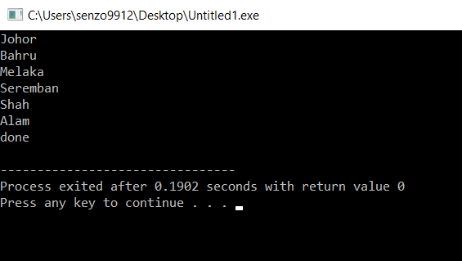

b) because the ifstream function assign 1 word as an input

c)inout.getline(city,50);

d)

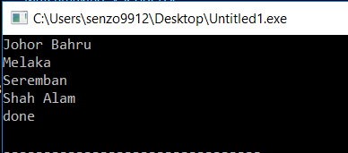

2. (A)

fstream file (“info.dat”,ios::out|ios::binary);

char c;

if(file.fail())

{ cout<<”Could not open the file.\n”; }

while(!file.eof())

{ file.read(c,sizeof(c));}

cout<<c; }

file.close();

2. (B)

fstream dataFile(“info.dat”,ios::out|ios::binary);

int x=5;

dataFile.write(reinterpret_cast<char*>(&x), sizeof(x));

dataFile.close();

2.(C)

fstream dataFile(“info.dat”,ios::in | ios::binary);

char text[81];

dataFile.read(text,81);

2.(D)

fstream dataFile(“info.dat”,ios::in | ios::binary);

char sentence[81] = “This is a testing sentence”;

dataFile.read(sentence,81);

2.(E)

fstream dataFile(“info.dat”,ios::in | ios::binary);

int y;

dataFile.seekp(10);

dataFile.read(reinterpret_cast<char*>(&y),sizeof(y));

4) a)#include<fstream>

b)fbook.open(“book.data”,ios::out|ios::binary);

c)fbook.write((char*)&book,sizeof(catalog))

d)

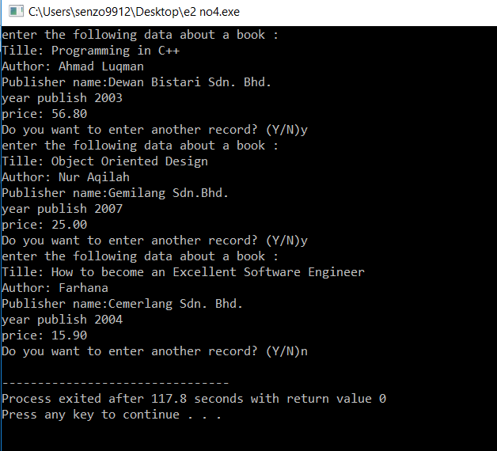

5)

1. To open a binary file and write the data to the other binary files which is named by the user
2. 1. To create the binary file named by the user and it defines the object of the fstream to be used

to write data or read data.

2. Move the file pointer to the last byte at the end of the file

Then it return the value of the position of the file pointer to the integer n

3. Move the file pointer to the first byte from the beginning

4. It read the first file and store every byte into char. Then it write every byte it stored to second

file.

1. It has to invoke with the size of the character instead of n.
2. Char data[20000];

Fin.read ( &data,n );

Fin.write( &data,n );

6)

a) fstream fbook("book.dat", ios::in|ios::binary);

b) fbook.read(reinterpret_cast<char*>(&book),sizeof(book));

c)

